Hands-On Practice Assignment

Practical Lab Tasks

Task 1: Filesystem Structure & File Management
- Identify your current working directory using pwd.
- Create a new directory structure named assignment_lab/stage1 using a single command (mkdir -p).
- Navigate into assignment_lab/stage1 and create three blank text files: data1.txt, data2.txt, and info.txt.
- Write the names of 5 states into data1.txt using cat > data1.txt or echo.
- Create a duplicate backup of data1.txt named data1_backup.txt.
- Create a soft link on your home directory named state_link pointing to data1.txt.
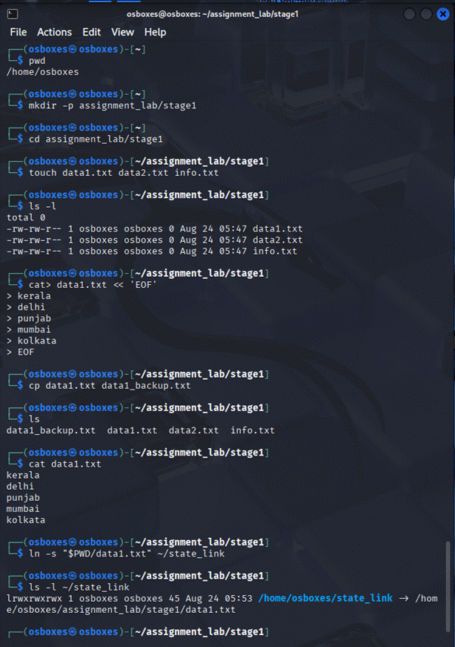

Task 2: Data Extraction & Sorting
- Display the contents of data1.txt from top to bottom using cat, and then in reverse order using tac.
- Sort data1.txt in reverse alphabetical order using sort -r.
- Search for state names ending with or containing the letter a using grep -i.
- Count the total words and lines present in data1.txt using wc.
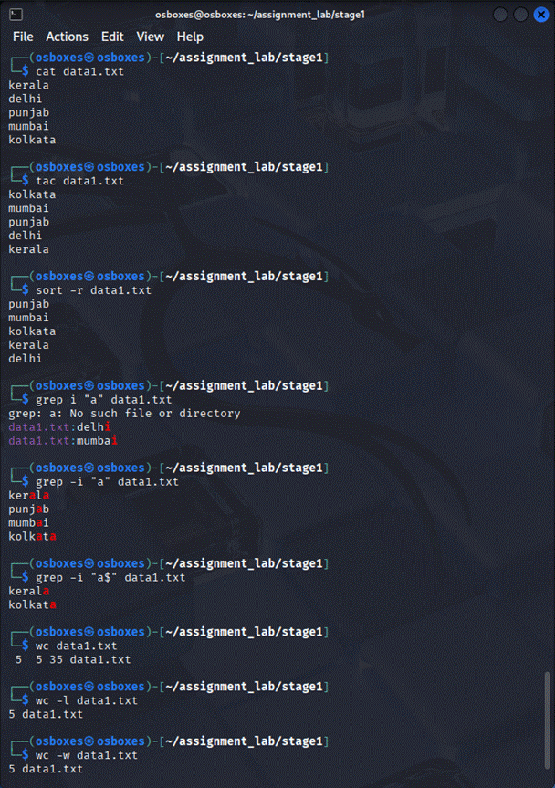

Task 3: Archival, Compression & Verification
- Bundle the entire assignment_lab folder into an archive file named assignment.tar using tar -cvf.
- Compress assignment.tar using gzip to generate assignment.tar.gz.
- Use file to verify the compression type of assignment.tar.gz.
- Preview the decompressed file structure using zcat or tar -tvf.
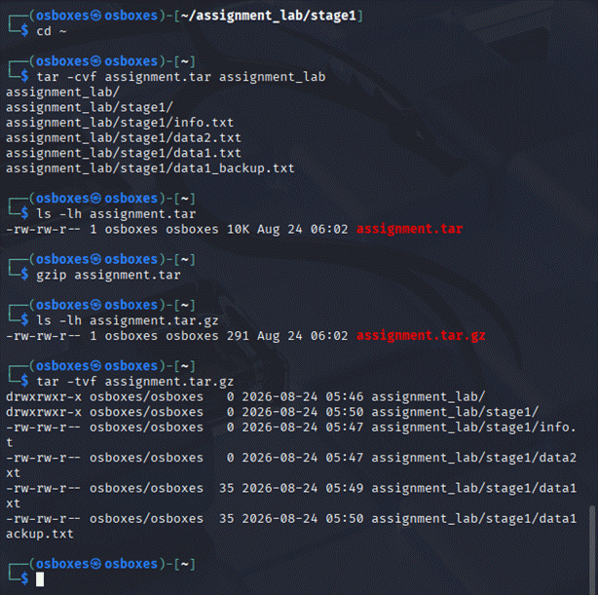

Task 4: System Diagnosis & Remote Monitoring
- Check your active username with whoami and system uptime with w.
- Calculate 1542 \times 8 directly from the command line using bc.
- Verify network reachability to 127.0.0.1 (localhost) sending exactly 3 packets with ping.
